Lecture 9: Competition: supply chains
Competition: supply chains
- Perfect competition
- Supply chains and marketing margins

Readings
- Mendoza, Gilberto (1995) “Chapter 11: A Primer on Marketing Channels and Margins,” in Scott, Gregory J., ed. (1995) Prices, Products, and People: Analyzing Agricultural Markets in Developing Countries. Lynne Rienner, Boulder.

Supplementary Readings
- Hill, E., J. Upton, A. Xavier, 2011. “Local and Regional Procurement in Uganda: Lessons learned from a pilot study of the Market Information and Food Insecurity Response Analysis (MIFIRA) framework. July. Draft. http://dyson.cornell.edu/faculty_sites/cbb2/MIFIRA/apps/
- MIFIRA Uganda Trader Survey 29 Sept 2010 comments: “Trader Interview: Individual Competition and Characteristics: wholesale and retail food staple traders” http://dyson.cornell.edu/faculty_sites/cbb2/MIFIRA/survey/

Information collected during market mapping about which products are purchased by whom, from where and on what terms, and how households access markets and at what cost can help to construct a supply chain for staple goods and identify when institutional or infrastructural problems associated with a crisis are likely to disrupt previous market participation patterns. Supply chains can pinpoint how market actors may be affected by a supply shock. Supply shocks can disrupt the movement of food along any point of the supply chain. For example, supply shocks can impact production through increased prices of inputs, production failures or shortfalls, changes in storage capacity, labor shortages, etc. Supply shocks can also occur following infrastructural damage, disruption to transportation, new regulations, conflict, and new trade policies.

Drafting supply chains can assist in identifying the link where competition is likely to bottleneck. Traders buy at one price and sell at another. The difference between prices is the gross per unit profit (which can be negative if traders sell at a loss). A marketing margin is the cost of equipment, transport, labor, capital, risk, and management associated with the buying and then selling of a product. Some of these are fixed costs (i.e., they do not vary with the volume transacted, such as the cost of equipment) while others are variable costs (e.g., the price paid per unit of commodity purchased). To remain in business, an organization’s gross per unit profit must be greater than or equal to the marketing margin. In the long run, marketing margins should be equivalent to the difference in prices. This implies that there is no opportunity to sustainably earn “pure” or excess profit because if such an opportunity exists, other traders enter the market, driving down prices back to the competitive level. By computing marketing margins at supply chain bottlenecks, it is possible to assess whether excess profits are being earned in the bottlenecks or whether traders are moving the product at a competitive price.

Perfect competition
Markets are either perfectly competitive or imperfectly competitive. Elements of a perfectly competitive market include:
- Fungibility and divisibility of commodities
- Buyers and sellers are maximizers
- Firms are small, numerous
- No barriers to entry
- Complete knowledge of supply and demand forces

These elements enable price-taking. Consumers and producers who are price takers, by definition, are unable to directly influence prices. Sellers that take prices as given remain in the market only if their per unit costs are less than or equal to the market price. Within commodity markets, (1) the number of firms and (2) the ease of entry and expansion are key indicators of supplier competitiveness. When these conditions are not met, it may be easy for traders to behave collusively, either to fix prices or control the supply of products.

Monopolies and oligopolies exist because other firms find it unprofitable or impossible to enter the market for some reason, in spite of the fact that the incumbent firm(s) earn(s) positive profits from trade. This implies the existence of entry and mobility barriers. An entry barrier keeps new firms from entering the business at all. Mobility barriers keep incumbent firms from expanding either the scale (i.e., volume) or scope (i.e., functions or products) of their existing business.

Barriers arise from any of several sources:
- Technical barriers arise when a significant minimum efficient scale of operation exists due to declining marginal costs of operation (e.g., for motorized transport)
- Legal barriers arise from state protections.
- Informal barriers arise due to sociocultural restrictions that limit physical access to certain areas or information access that may be essential to arbitrage or to contract enforcement.
- Firm-created barriers emerge where firms actively work to exclude others from the market through costly investments of their own, especially investments that are effectively irreversible (so-called “sunk costs”).
Imperfect markets will be discussed further in the next lecture.

We use other analyses, such as market integration measures and import parity price analysis to determine whether traders are responsive to market signals. We can then employ supply chains and marketing margins to examine whether profits appear excessive. Where profits are excessive in any link (or segment) in the supply chain, then that link is not currently competitive.

Supply chains and marketing margins
A supply chain identifies how goods and services flow through an economy. Supply chains can also map the underlying costs associated with moving a product from a center to a specific location. Specifically, marketing margin analyses trace out the marketing costs associated with each step along the supply chain. In emergency situations, constructing supply chains can provide information on how markets functioned before the crisis and what constraints they now face.

We use supply chain mapping to disaggregate the commodity supply chain into distinct functions – e.g., farm-level collection and assembly, wholesaling, transport, milling, interseasonal storage, retailing – just as we commonly disaggregate the national market into distinct geographic locations. Then, look for entry or mobility barriers that inhibit growth in marketing intermediaries’ throughput volume and specific bottlenecks associated with noncompetitive behavior.

Some market segments are more susceptible to non-competitive behavior than others. Focusing on those segments with the fewest competitive elements may decrease the data collection and time burden associated with assessing the competitiveness of a market channel. For example, if many retailers are active and ease of entry and exit seem well-established, focus on other aspects of the supply chain where there are fewer competitors and higher barriers to entry, such as long-haul transportation, interseasonal storage, milling, and wholesaling.

If a market segment appears not to be competitive, ask traders who either sell or buy from the segment of interest about how easy or difficult it is to enter that market segment, what sorts of barriers exist and why, and how many new entrants there have been in the past few years.

Traders commonly closely guard information on market share, so it can be tough to collect precise data. One must often rely on qualitative assessments and indirect observations (e.g., all the lorries seem to belong to the same firm; there is only one large-scale commercial mill in the region for grinding grain into flour).

Even then, the implications for expected price changes are not immediately clear, although when markets are noncompetitive, the rate of price increases is typically half again higher or double the rate under perfect competition due to oligopolistic mark-ups.

How does constructing supply chains assist in answering the relevant MIFIRA sub-question?
1d. Do local traders behave competitively?
If traders compete, food prices for food insecure households should increase only as much as costs for traders increase. If traders can exercise market power, however, then they can extract added profits from increased demand by boosting prices faster than costs increase. By examining marketing margins, we can assess whether profits are currently aligned with marketing costs or if certain market actors in a supply chain are earning excess profits.

2b. Will agency purchases drive up food prices excessively in source markets?
If local or regional purchases will significantly bid up food prices in source markets, perhaps due to anti-competitive behavior, these actions can harm food insecure households within the source market. The objective is to winnow the list of prospective source markets identified in 2a. By examining supply chains, we can identify whether traders are already moving product from source to local markets, and at what cost.

How to compute / estimate supply chains
Supply chains link market actors for a particular commodity or set of commodities (e.g., maize and soy separately linking to corn-soy blend processing). Below is an example of a supply chain that examines maize movement from producers to urban consumers and to export markets. Many chains in secondary literature focus on evacuation of product from rural areas to urban areas. In fact, evacuation supply chains explicitly consider how food moves to food insecure areas.

Note that this chain does not examine how such maize may return to rural net-buyers, as occurs with seasonal flow reversals (discussed in the previous lecture). Often supply chains, such as the one below, reverse during lean seasons. The commodity supply chain analysis should address movement of food into food insecure areas and should be explicitly discussed with traders and key informants.

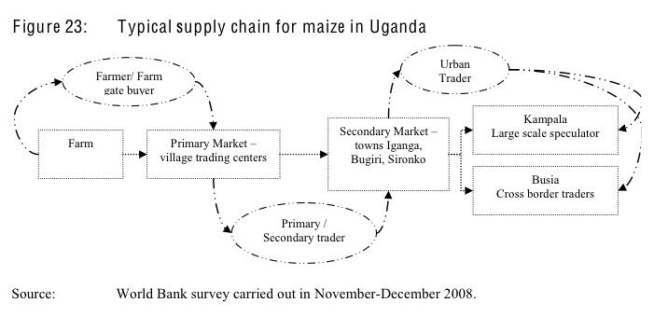

While the above chain is relatively straightforward, some supply chains have more complex linkages such as the marketing channel below, which maps grain trade originating in the Darfur region of Sudan. This chain includes multiple types of consumers and producers.

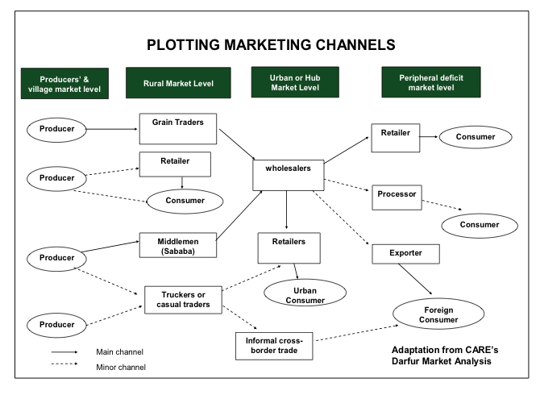
Source: FEWS NET (2009), Lesson 2, p. 25.

Given that MIFIRA’s focus is on food moving to food insecure areas, certain avenues within a supply chain will likely warrant more attention than others. For example, if food insecurity in urban areas is the primary concern, focusing on major channels from producers to middlemen and grain traders to wholesalers to retailers to urban consumers is more helpful than looking at a chains involving informal export trade. Similarly, identify whether there is a strict differentiation among urban wholesalers. If there is a differentiation, speaking with wholesalers who supply urban retailers will be more useful than speaking with wholesalers who export.

Identify actors (Step 1)
To link different types of traders to one another and to identify major and minor trade channels, ask major traders and market actors the following questions:

- From whom and where do they buy?
- How many suppliers do they have?
- To whom and where do they sell?
- How many customers do they have?
- At what prices? On what dates?

Use these findings to draft likely supply chains. The figure below documents from where a trader buys and to whom the trader sells (EMMA, 2009).
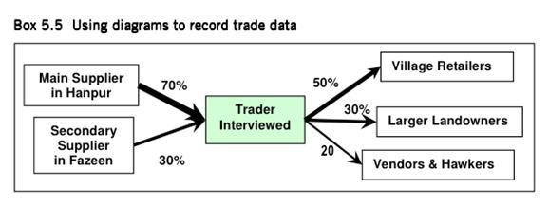
Source: Albu (2010), Emergency Market Mapping and Analysis Toolkit

A great deal of diversity in the types of traders is common. Barrett (1997) found in the Malagasy rice market that not all segments are equally competitive. While there were many small retailers, due to credit constraints and other barriers, there were relatively few wholesalers and regional transporters. Therefore, some market segments are more susceptible to non-competitive behavior. Focusing on those segments with the fewest competitive elements may decrease the data collection and time burden.

Categorize actors (Step 2)
If feasible, verify information by speaking with downstream and upstream traders.
In order to adequately capture what the supply chain looks like, categorize traders based on:
- Typical supply routes
- To whom they sell and from whom they buy
- Monthly volumes of sale
- Types of transport they own or have access to
- Credit they can leverage
- Food storage options
- Common constraints

Other information such as trader counts and volumes can be included as well. Draft the supply chain, indicating major and minor channels. The below EMMA market system map overlays supply chains with the number of traders in each segment and the volumes passing through each segment. This map focuses on the sources of a particular commodity (e.g., beans) that consumers in this particular region can access.

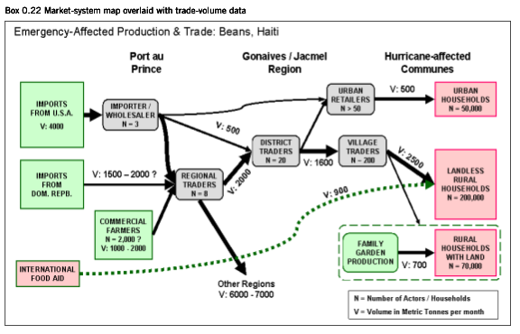
Source: Albu (2010), Emergency Market Mapping and Analysis Toolkit

Supply chains and marketing margins often implicitly consider small-scale sellers as the starting point of the chain and urban consumers or processors as the end-point. While evacuation of surplus from rural areas is an important source of income for sellers, information on how food moves into deficit areas or into areas with many households with collapsing access is less frequently available from secondary sources. In a MIFIRA analysis, we need to consider how products move from wholesalers to (food insecure) consumers, including rural consumers.

Compute marketing margins (Step 3)
By eliciting prices paid and sold, and fixed and variable costs from traders, it is possible to compute gross per unit profits and costs (margins) along the supply chain, for example from the wholesaler at the marketing hub to margins for the wholesaler at the local market to margins for the retailer at the local market. This can be expanded as necessary to include additional links in the supply chain.

Ask traders for the prices they bought at and the prices they sold at. This allows us to compute their gross per unit profits as the difference between purchase price and sales price. We can then compute marketing costs by examining fixed and variable costs paid by traders. If their marketing costs are substantially below gross profits (the product of volumes transacted and the gross per unit profit), then they may be earning excess profits.

Marketing margins include both fixed (salaries, storage rental, security) and variable cost (bagging, processing, transportation, bribes, ad valorem tariffs, credit, loading or unloading) elements. We can estimate margins along the supply chain by disaggregating prices from buyer back to original source (i.e., household retail purchase price = retailer costs (staffing, storage, credit, capital depreciation, taxes) + retailer profits + wholesaler costs (transport, storage, credit, staffing, capital depreciation, taxes) + wholesaler profits + transport charges (including road tolls, taxes) + tariff charges + import parity price).

Marketing margins can be computed in absolute or percentage terms. Note that traders often trade in many commodities. Therefore, apportion fixed costs to a given commodity by revenue or volume for that particular trader.

Data requirements
Data typically come from trader and key informant interviews (e.g., bankers, transporters, importers, governmental officials). Trader information should be crosschecked against data collected from downstream and upstream market actors.
It is often best to start with staple retailers and wholesalers in the major local markets relied on by target communities. Ask these traders for information on those who purchase from them and those who sell to them. Interview upstream and downstream traders with characteristics similar to the characteristics described by traders in the first round.

Donovan et al. (2006, p. 34) suggest that 10% of traders (and a minimum of 10 traders) should be interviewed in large public (i.e., retail) markets. At the wholesale market level, at least 5 traders should be interviewed in each location (town, city-center etc.).

Below is an example of variable and fixed costs from a trader survey in northern Kenya. Note that the variable costs consider average costs per purchase trip, while the fixed costs are per month. In order to compute marginal costs, we also need to know the average amount purchased on such a trip. Some costs that are variable in northern Kenya, such as security costs, may be monthly costs in other locations. Therefore, key informant discussions with traders about the types of costs they incur and whether they incur them per trip or per month can help differentiate which costs should be treated as fixed and which should be treated as variable.

Average Costs on a Purchase Trip | KShs
Transport costs from your supplier to your business
Security Costs
Bribes
Loading / unloading if not done by your employee
Bagging
Losses
Other (specify):
Other (specify):
Average volume purchased on a trip

Monthly Costs | KShs
Rent
Extra storage costs
Labor
Average monthly fees (e.g., license, tax, council fees)
Communications
Vehicle maintenance
Security Costs
Bribes
Credit payments
Transformation / processing
Other costs:
Other costs:

Interpreting supply chains and marketing margins
The below example shows marketing margins by market segment. The marketing cost are just for the farm gate to wholesale market portion of the supply chain. There are additional costs to move the product from wholesalers to consumers. Transportation is the dominant market cost for most market segments, comprising 76% of marketing costs. Note that “cess” is an import or sales tax.
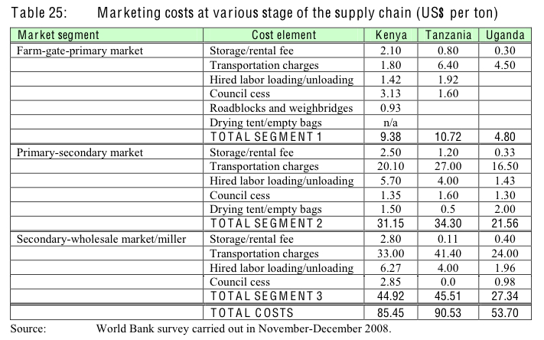

In this particular example, the authors further disaggregated transport costs because it is such a major cost. If a particular segment is of more interest, it is possible to disaggregate that segment into its component parts. Below is an example of variable and fixed costs per country for maize transporters.
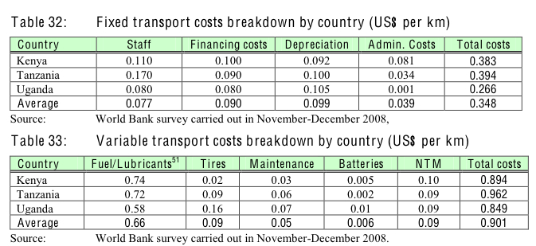

Source: World Bank – Agriculture and Rural Development Sustainable Development Network (2009) “Eastern Africa: A Study of the Regional Maize Market and Marketing Costs.” World Bank. Report No. 49831 - AFTAR.

The disaggregated data can identify what aspects of the supply chain are most costly as well as estimate profit margins for traders for each segment of the marketing chain. If traders’ costs are much lower than their profits, they may be colluding, and the market may not be adequately functioning to distribute cash.

This World Bank study tried to assess all indirect and direct costs of transporters. The authors argue that transporters’ profits are not very high and are only achievable by relying on secondhand trucks and, in Kenya and Tanzania, by overloading their vehicles. The authors do acknowledge that backhauling may impact profitability so these profit estimates are not complete and may understate profitability. Here, margins analysis helps identify what profit rates are for one direction of trade and whether they appear excessive.

There are often higher margins at source markets compared to at retail markets because there are more risks and larger costs, such as losses due to drying, storage, and pests, more expensive transportation costs for aggregators, and information asymmetries, especially relative to small farmer suppliers.

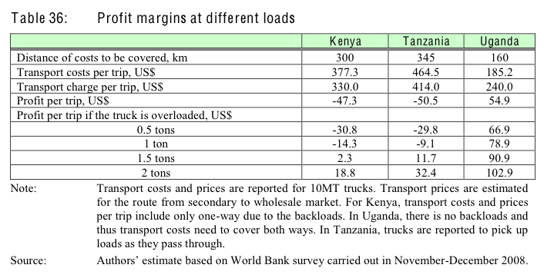
Limitations of supply chain and marketing margin approach
While major market actors are a key source of information about supply responsiveness, it can be difficult and time intensive to elicit and verify supply information from traders, who may consider such information proprietary. Further, if traders perceive that their answer could be use in support of a particular intervention, they may have incentives to overstate their ability to meet demand. Breaking the sample into two groups (e.g., those who speak about gross profit, and those who speak about marketing margins) may be one approach to triangulating the data.

Mendoza (1995) argues that marketing margins are often fairly stable over time. However, margins may fluctuate in response to exogenous factors, such as rises in fuel prices and infrastructural changes. Furthermore, a trader may not have the same proportional marketing margin for different products. For example, a trader may make a small margin on trading basic staples, but a higher (proportional) margin on trading more expensive goods, such as soaps and detergents. Similarly, while marketing margins should be roughly similar across traders operating within a segment (e.g., retailers who purchase from wholesalers), marketing margins will not be the same across segments.

Information on value chains
Each link in a value chain reflects the value added by transforming or processing the product until it reaches the customer. Value is often defined from the perspective of the customer. Supply chains focus rather on how a products moves from the initial producer to the customer; value addition is not a requirement in supply chains and each link represents a different actor taking possession of the product.

USAID MicroLinks Wiki on Value Chain Development:
http://apps.develebridge.net/amap/index.php/Value_Chain_Development
Sample questions regarding supply chains and marketing margins
In the annotated trader survey for Uganda, several questions can help analysts to understand more about the trader’s size and business activity, the trader’s upstream suppliers and downstream consumers, and the trader’s marketing margins.

Section A, questions 1-7, 10 and 11, and Section D, questions 1 and 13, describe the respondent-trader characteristics
Section B, questions 1-3, describe suppliers’ characteristics
Section C, questions 1-8, describe consumers’ characteristics
Section B, questions 10-12, describe marketing margins

